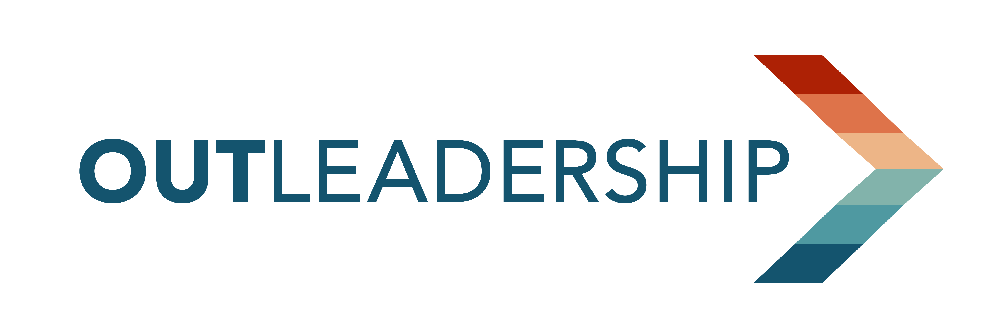

FOR IMMEDIATE RELEASE: Thursday, June 1, 2023
CONTACT: Kristofer Eisenla, LUNA+EISENLA
kristofer@lunaeisenla.com | 202-670-5747 (mobile)
The Best and Worst States for LGBTQ+ Equality

Out Leadership’s 2023 State LGBTQ+ Business Climate Index finds “the state of LGBTQ+ access and equality in the U.S. is regressing”

NEW YORK CITY, NY – This year for the first time since Out Leadership began publishing the State LGBTQ+ Business Climate Index five years ago, the nation’s overall average score on LGBTQ+ equality dropped -1.14 points. The net negative rating for the country is largely due to over 500 anti-equality bills introduced at the state level this legislative cycle.

The 2023 State LGBTQ+ Business Climate Index released by Out Leadership, the premier global LGBTQ+ organization harnessing the power of business to drive equality, finds “the state of LGBTQ+ access and equality in the U.S. is regressing,” signaling “increasing polarization across the country in political and cultural attitudes towards the LGBTQ+ community.”

“The State LGBTQ+ Business Climate Index ranks each state and applies a numeric score out of 100 for how LGBTQ+ people experience living, working, building a family and building a life in each state. We use data from our partners at the Williams institute and LGBTMAP (Measurement advancement project) as well as our own research to measure lived experience for LGBTQ+ people in each state,” explains Jane Barry-Moran, Managing Director, Research & Programs, Out Leadership.

Top 5 states for LGBTQ+ equality

1) New York – 93.67
2) Connecticut – 93.27
3) Massachusetts – 92.67
4) New Jersey – 90.00
5) Colorado – 88.67
Worst 5 states for LGBTQ+ equality

46) South Dakota -- 34.97
47) Tennessee – 34.40
48) Louisiana – 33.50
49) South Carolina – 32.50
50) Arkansas – 32.00

** The background document below gives key data points from this year’s State LGBTQ+ Business Climate Index. The full index can also be viewed here. **

“As greater numbers of multinational companies continue to shift away from U.S. based operations, the business impact of this year’s index points to a harmful effect for the nation’s economy and job market,” said Todd Sears, founder and CEO of Out Leadership. “Major corporate employers want to locate to places where they can recruit the best talent, without having to worry about state and local laws hindering their overall business success. Companies simply don’t want to be at odds with the business policies and practices of the state they operate in, and they certainly don’t want to feel attacked by them.”

Some of this year’s drivers responsible for the change in rankings include a range of anti-LGBTQ+ pieces of legislation targeting gender-affirming care, censorship laws like “Don’t say gay,” limits on transgender adult and youth rights, and the change in pro-LGBTQ+ leadership in the state.

“While the top ranked states for LGBTQ+ equality broadly are staying strong, the bottom ranked states decreased in score significantly. This continues to signal increasing polarization across the country in political and cultural attitudes toward the LGBTQ+ community,” said Brian Sims, Managing Director, Public Policy and Government Affairs for Out Leadership.

Out Leadership’s State LGBTQ+ Business Climate Index is an assessment of all 50 states’ performance on LGBTQ+ inclusion. The index measures the impact government policies and prevalent attitudes have on LGBTQ+ people residing in each state, quantifying the economic imperatives for inclusion and the costs of discrimination. It is a multidimensional index based on a broad array of markers of policies, attitudes, and measurements relating to LGBTQ+ inclusion. These markers are carefully chosen to accurately reflect the experiences of LGBTQ+ people in each state. You can view the index’s methodology, here.
Sears concluded, “The economic outlook of anti-equality states is being imperiled by politicians more interested in scoring political points than protecting the future livelihoods of citizens.”

Out Leadership recently released its annual OutQUORUM report, LGBTQ+ Board Diversity: Progress & Possibility, showing for the first time in history more than half of all Nasdaq-listed companies now have board diversity policies covering LGBTQ+, gender, race, ethnicity, and national origin.

For more information about the State LGBTQ+ Business Climate Index and/or to schedule interviews, please contact Kristofer Eisenla at kristofer@lunaeisenla.com

# # #

About Out Leadership
Out Leadership is the premier global platform utilized for over a decade by many of the world’s greatest companies, nonprofits, and governments to drive equality through business. For over a decade, Out Leadership has advocated for greater board diversity through talent development, research, thought leadership, and professional networking opportunities. To learn more visit: outleadership.com.

BACKGROUND
2023 State LGBTQ+ Business Climate Index
It matters to companies, including their employees and families, when a state has supportive LGBTQ+ policies. Those state legislative policies effect every part of a business’ activity from recruiting and retaining top talent and local laws conflicting with internal policies and the values of large multi-national companies and the customers they serve.
Key Data Points from the 2023 State LGBTQ+ Business Climate Index
- More than half of the over 500 anti-LGBTQ+ bill proposed in state legislatures this cycle were targeting the transgender community.
- The largest changes in scores between 2022-2023 were driven by Legal and Nondiscrimination Protections, Youth and Family Support, and Political and Religious Attitudes. States with the largest score increases, such as West Virginia, North Carolina, and Colorado, adopted pro-LGBTQ+ laws and protections across a diverse range of policy areas.
- This year’s Index reveals the impact of recent anti-LGBTQ+ legislation in states such as Florida, Arkansas, Tennessee, Indiana, and Kentucky.
- Florida’s “Don’t Say Gay” bill, amongst other anti-LGBTQ+ state legislation, caused the state to fall 2.83 points since 2022 and a 6.23 point decrease since 2021 – a major drop in the rankings. The infamous “Don’t Say Gay” bill has instigated similar bills across the United States, resulting in point decreases across the board.
- The continuous focus on limiting trans rights and access is also a major driver of scores decreasing.
- Key drivers in anti-LGBTQ+ equality state legislative proposals fall along several areas, including:
  - Healthcare bills focuses on Gender affirming care.
  - Censorship laws like the “Don’t Say Gay” bill.
  - Legislation limiting the rights and access of trans youth and adults.
  - Changes in state leadership from pro-LGBTQ+ leaders to anti-LGBTQ+ leaders (2022 elections of new senators and governors).

- New York is the highest-ranking state in LGBTQ+ equality for a third year in a row, scoring 93.67 out of 100 points.
- Arkansas is the lowest ranking state in LGBTQ+ equality for the first year, passing South Carolina with a score of 32.00 out of 100 points.
- The highest mover was West Virginia, with an increase of 5.47 points between 2022 and 2023. This was due to the broad implementation of pro-LGBTQ+ policies (particularly benefitting the trans community) across legal & nondiscrimination protection, youth & family support, and health access & safety.

